# RFID BASED AUTOMATED ATTENDANCE SYSTEM USING ARDIUNO

### MINI PROJECT REPORT

for

21CSS201T - COMPUTER ORGANIZATION AND ARCHITECTURE

*Submitted by*

Krish Jhawar [RA2311033010070]

Rishika Sarkar [RA2311033010071]

*Under the Guidance of*

Dr. S. Abijah Roseline

(Assistant Professor, Department of Computational Intelligence)

*In partial fulfillment of the requirements for the degree of*

BACHELOR OF TECHNOLOGY

in

COMPUTER SCIENCE ENGINEERING



DEPARTMENT OF COMPUTATIONAL INTELLIGENCE

SRM INSTITUTE OF SCIENCE AND TECHNOLOGY

KATTANKULATHUR- 603 203

### NOVEMBER 2024

SRM INSTITUTE OF SCIENCE AND TECHNOLOGY KATTANKULATHUR – 603 203

BONAFIDE CERTIFICATE

Certified that Computer Architecture and organization Mini Project report titled “ **RFID based Automated Attendance System using Ardiuno** ” is the bonafide work of “**Krish Jhawar” [RA2311033010070],** “**Rishika Sarkar” [RA2311033010071],** who carried out the project work under my supervision. Certified further, that to the best of my knowledge the work reported herein does not form any other work.

#### Dr.S.ABIJAH ROSELINE

**Guide**

Assistant Professor

Dept. of Computational Intelligence

#### Dr. R ANNIE UTHRA

**Professor & Head** Dept. of Computational Intelligence

## SRM Institute of Science and Technology College of Engineering and Technology

**SCHOOL OF COMPUTING**

**MINI PROJECT REPORT**

**ODD Semester: 2024-2025**

Sub code & Sub Name : 21CSS201T & Computer Organization and Architecture Year & Semester : II & III

Project Title : RFID based Automated Attendance System using Ardiuno

Team Members : 1. Krish Jhawar ( Reg.No: RA2311033010070)

1. Rishika Sarkar ( Reg.No: RA2311033010071)

|  |  |  |
| --- | --- | --- |
| Particulars | Max Marks | Marks Obtained |
| Program & Execution | 20 |  |
| Demo verification & Viva | 15 |  |
| Project Report | 05 |  |
| Total | 40 |  |

**Date :**

**Staff Name :**

**Signature :**

|  |  |  |  |
| --- | --- | --- | --- |
| **CHAPTER NO** | **INDEX** | **TITLE** | **PageNo** |
| 1 | OBJECTIVE |  | 5 |
| 2 | ABSTRACT |  | 6 |
| 3 | INTRODUCTION |  | 7 |

HARDWARE & SOFTWARE

4

REQUIREMENTS 8-9

1. CONCEPTS WORKING PRINCIPLE 10-13
2. PROGRAM 14-16
3. OUTPUT 17
4. CONCLUSIONS 18
5. REFERENCES 19

# RFID BASED AUTOMATED ATTENDANCE SYSTEM USING ARDIUNO

## OBJECTIVE:

## The primary aim of this project is to design and implement an automated attendance and access control system that combines Arduino microcontroller technology with RFID-based identification and servo motor functionality. In this system, each individual is assigned an RFID tag or card, which they scan upon entry. This scan captures essential attendance details—such as the name, roll number, and time of entry—which are automatically recorded in an Excel sheet, streamlining the attendance tracking process. This automation minimizes human error and effort in attendance management while ensuring data accuracy and quick retrieval.

## The system is also designed with security in mind, as it restricts access based on recorded attendance. After a brief delay following the successful registration of attendance, the Arduino activates a servo motor to unlock the door, granting access to authorized personnel only. This delay allows for secure, real-time data logging and ensures that only those whose attendance is logged can enter. This approach provides a streamlined access control process that is especially useful in environments like educational institutions, offices, and restricted facilities where both attendance tracking and secure access are essential.

## By integrating RFID technology with Arduino-based automation, this project brings together attendance tracking and physical access control into one cohesive system. The Arduino acts as the central controller, processing data from the RFID reader and managing door access through the servo motor. The Excel sheet serves as a centralized database for attendance records, allowing easy data management and report generation as needed. This efficient combination of technologies simplifies daily attendance tasks, reduces manual intervention, and improves security.

## Ultimately, this project provides a versatile solution that enhances operational efficiency by automating attendance and access control within restricted areas. It offers a scalable model that can be adapted for various institutions and organizations, providing a secure, accurate, and user-friendly system that reduces administrative workload, secures access, and supports reliable attendance documentation.

## ABSTRACT:

This project provides an effective, automated solution for attendance management and secure access control, leveraging the capabilities of an Arduino microcontroller, RFID technology, and a servo motor. The system is designed to automate the tracking of individuals’ attendance by using RFID tags or cards, each assigned with unique identification data. When a tag is scanned, the system captures critical information—such as the individual’s name, roll number, and the exact time of entry—and stores it in an Excel sheet, ensuring reliable and easy-to-access records. The system incorporates a brief time delay after each scan, allowing for secure data logging and helping to prevent duplicate entries.

A key feature of this system is its ability to control access with a servo motor, which is activated to unlock the door only after an individual’s attendance has been successfully recorded. This integration of attendance tracking and access control provides an additional layer of security, ensuring that only registered individuals can enter restricted areas. This functionality is particularly valuable in environments where monitoring attendance and controlling access are essential, such as in classrooms, offices, or secured facilities. By automating both attendance recording and entry authorization, the system minimizes manual oversight, reduces the potential for errors, and enhances overall security.

This system's scalability and flexibility make it adaptable to various organizational needs. Built with cost-effective components like the Arduino Uno, RC522 RFID reader, and a simple servo motor, it provides a reliable and budget-friendly solution that can be easily deployed and maintained. The RFID technology ensures quick identification, while the Arduino’s versatile control over input-output operations enables seamless interaction with both the RFID reader and the servo motor. The use of Excel for attendance record storage further simplifies data management, making it easy to track, retrieve, and analyze attendance data as needed.

In summary, this project demonstrates how combining automation with secure access control can provide a comprehensive, efficient solution for attendance management. It not only saves time and resources by automating routine tasks but also contributes to security by restricting access to authorized individuals. With its versatility and efficiency, this system offers a valuable application of technology for any setting where attendance and controlled access are a priority.

## INTRODUCTION:

In traditional attendance systems, the manual recording of attendance data can be tedious, error-prone, and inefficient, especially in environments that require strict monitoring. Recording attendance manually not only consumes significant time but also introduces the risk of inaccuracies that can lead to complications in record-keeping and security. With advancements in Radio Frequency Identification (RFID) technology, attendance management can now be automated, offering greater reliability, speed, and accuracy. RFID-based systems allow each individual to scan an assigned card or tag, significantly simplifying the attendance process and reducing the potential for human error.

This project leverages an Arduino microcontroller to integrate an automated attendance system with door access control. When an RFID tag or card is scanned, the Arduino captures the essential details, such as the individual’s name, roll number, and time of entry, and stores this information in an Excel sheet. This automated logging facilitates efficient data retrieval and management, making it easier to keep accurate records over time. Moreover, the system goes beyond mere attendance tracking by adding an access control mechanism: a servo motor is connected to the Arduino, unlocking the door after successful attendance registration. This feature restricts entry to authorized individuals only, enhancing the security of restricted areas like classrooms, offices, and secure facilities.

The design of this system emphasizes simplicity, cost-effectiveness, and scalability, making it adaptable to various applications. With minimal hardware—a standard Arduino, an RFID reader, and a servo motor—this system can be easily implemented without requiring complex components or extensive maintenance. Its low cost and easy setup make it ideal for educational institutions, small businesses, and other settings where automated attendance tracking and access control would streamline operations. Additionally, by recording data in Excel, this system offers a straightforward way to generate reports, monitor attendance patterns, and track access history.

In summary, this Arduino-based attendance and access control system combines the efficiency of automated attendance with the security of controlled entry. By using RFID technology and servo motor integration, it addresses the limitations of manual attendance tracking while providing a practical solution for secure access. This project demonstrates how automation and technology can simplify everyday processes, increase accuracy, and improve security, ultimately offering a versatile model that could be adapted to a wide range of environments requiring efficient attendance management and restricted access control.

## HARDWARE/SOFTWARE REQUIREMENTS:

**Hardware:**

1. Arduino Uno: The Arduino Uno is a microcontroller board that serves as the main control unit of the system. It reads data from the RFID reader, processes it, and sends commands to the servo motor. The Arduino Uno is well-suited for projects that require input-output (I/O) control and is versatile enough to interface with multiple components like sensors, motors, and other peripherals. In this project, it acts as the “brain,” coordinating data flow between the RFID reader and the servo motor to manage attendance and door access.
2. RFID Reader (RC522): The RC522 RFID reader module is used to read RFID tags and cards assigned to each individual. When a tag or card is placed near the reader, it reads the unique ID of the card and sends this information to the Arduino. This module operates on a 13.56 MHz frequency, which is compatible with most standard RFID cards and tags, making it a practical and reliable choice for identification tasks in attendance systems.
3. Servo Motor: The servo motor in this system is responsible for physically locking and unlocking the door. Upon successful registration of attendance, the Arduino sends a signal to the servo motor to turn, temporarily unlocking the door to allow access. This controlled movement provides an efficient access control mechanism, as the motor only unlocks the door when an authorized RFID card is scanned.
4. RFID Tags/Cards: RFID tags and cards are unique identifiers assigned to individuals. Each tag/card contains a unique ID that the RFID reader can recognize. When scanned, these cards allow individuals to register their attendance by communicating their unique ID to the system, which then logs the details and controls access.
5. Jumper Wires: Jumper wires are essential for connecting all components in this project. They are used to link the Arduino with the RFID reader, servo motor, and any other necessary circuitry on a breadboard. These connections enable the components to communicate and work together effectively, forming a complete and functional circuit for the system.

**Software:**

1. Arduino IDE: The Arduino Integrated Development Environment (IDE) is used to write, compile, and upload code to the Arduino board. This software provides a platform for coding the logic that controls the RFID reader, processes attendance data, and manages the servo motor. The Arduino IDE also includes tools for testing, debugging, and refining the code to ensure smooth operation of the system.
2. Microsoft Excel: Microsoft Excel is used to manage and store attendance data. Once the Arduino captures and sends attendance data via serial communication, Excel can store it in a structured format. This allows for easy tracking of attendance, report generation, and record management. Excel’s ability to handle large datasets and create reports makes it an ideal choice for logging attendance details.
3. RFID Library for Arduino: The RFID library is essential for enabling communication between the Arduino and the RC522 RFID reader module. This library contains predefined functions for reading the RFID card IDs, sending data to the Arduino, and handling other interactions with the RFID module. It simplifies programming tasks by offering ready-made code functions specifically for RFID technology.
4. Servo Library for Arduino: The Servo library provides predefined functions to control the movements of the servo motor. This library is used to define the range and position of the servo motor’s movements, ensuring it unlocks the door only after attendance is successfully logged. The library enables smooth motor operation, which is critical for controlled door access.
5. Excel/CSV Export Tools: These tools, although optional, are useful for exporting attendance data from the Arduino to Excel in CSV format. They provide a way to organize and archive attendance data, making it easier to share, analyze, or print records when needed. CSV export allows data to be saved in a universally compatible format, ensuring access across various platforms.

## CONCEPTS/WORKING PRINCIPLE

**Concept of our Attendance System-**

This project leverages Arduino and RFID technology to automate attendance management and secure access to restricted areas. It integrates an RFID-based identification system with a servo motor for door control, designed to streamline attendance tracking and enhance security. The system is particularly useful in environments like classrooms, offices, labs, and other areas requiring both attendance monitoring and restricted access control.

**Working Principle-**

* **RFID Scanning and Identification:** Each user is assigned a unique RFID tag or card. When a user scans their tag, the RFID reader (RC522 module) identifies the tag’s ID and sends it to the Arduino microcontroller. The Arduino processes the ID and determines whether the user is authorized.
* **Data Logging in Excel:** Upon recognizing a valid tag, the Arduino logs the user’s details, such as name, roll number, and timestamp, into an Excel sheet through serial communication. This automated process reduces the need for manual entry, minimizing human error and ensuring accurate attendance records.
* **Access Control with Servo Motor:** After attendance is successfully recorded, the Arduino sends a signal to the connected servo motor. A brief delay (1-2 seconds) is introduced to ensure the attendance data is logged before the door is unlocked. The servo motor controls the locking mechanism, providing access only to authorized users who have successfully registered their attendance.
* **Error Handling and Security:** If an invalid RFID tag is scanned, the Arduino denies access and does not log the attendance. In some cases, the system can log the unauthorized attempt for security purposes. This ensures unauthorized users cannot gain entry, and all attempts are tracked for further review.

**System Benefits and Efficiency:**

This automated system eliminates manual attendance tracking and reduces paperwork, offering a more reliable and secure solution. By combining attendance management with access control, it ensures that only authorized individuals can enter secure areas. The use of RFID technology enables fast, accurate identification, while the Arduino serves as a versatile control unit, managing both the RFID reader and the servo motor for door control. The overall system enhances security, improves efficiency, and reduces the potential for errors associated with manual processes.

**Block Diagram:**

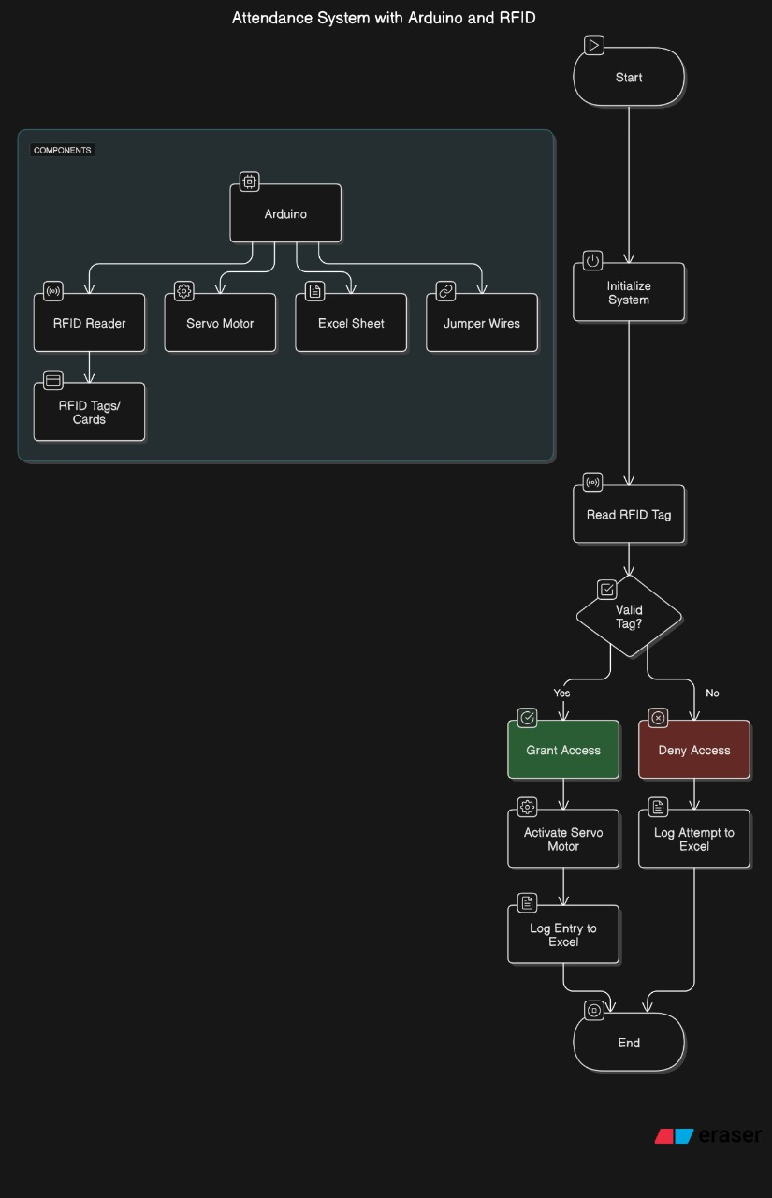

**Flow Of Control:**

1. Start the System: The system is powered on, and all components initialize to prepare for operation.
2. Initialize System Components: The Arduino initializes connected components, including the RFID reader (to read tags), servo motor (to control access), and an Excel interface (for logging attendance). This setup ensures that each part of the system is ready to function correctly.
3. Read RFID Tag: When a user taps an RFID card on the reader, the RFID reader detects and reads the unique ID from the card. This ID is then sent to the Arduino for validation.
4. Check if Tag is Valid: The Arduino compares the scanned RFID tag against a pre-stored list of authorized IDs
5. If Valid (the ID matches one of the authorized IDs):
   * **Grant Access**: The system proceeds to open the door.
   * **Activate Servo Motor**: The servo motor rotates or moves to allow the door or gate to open, providing access to the user.
   * **Log Entry to Excel**: An entry is added to the Excel sheet to record the access, including the user’s ID and timestamp.
6. If Not Valid (the ID does not match any authorized ID):
   * **Deny Access**: Access is denied, and the door remains closed.
   * **Log Attempt to Excel**: An entry is added to the Excel sheet to log this unauthorized attempt, recording the time and RFID tag used.
7. End Process: The system returns to its initial state, waiting for the next RFID card to be tapped, and the process repeats.

## Architecture Diagram:

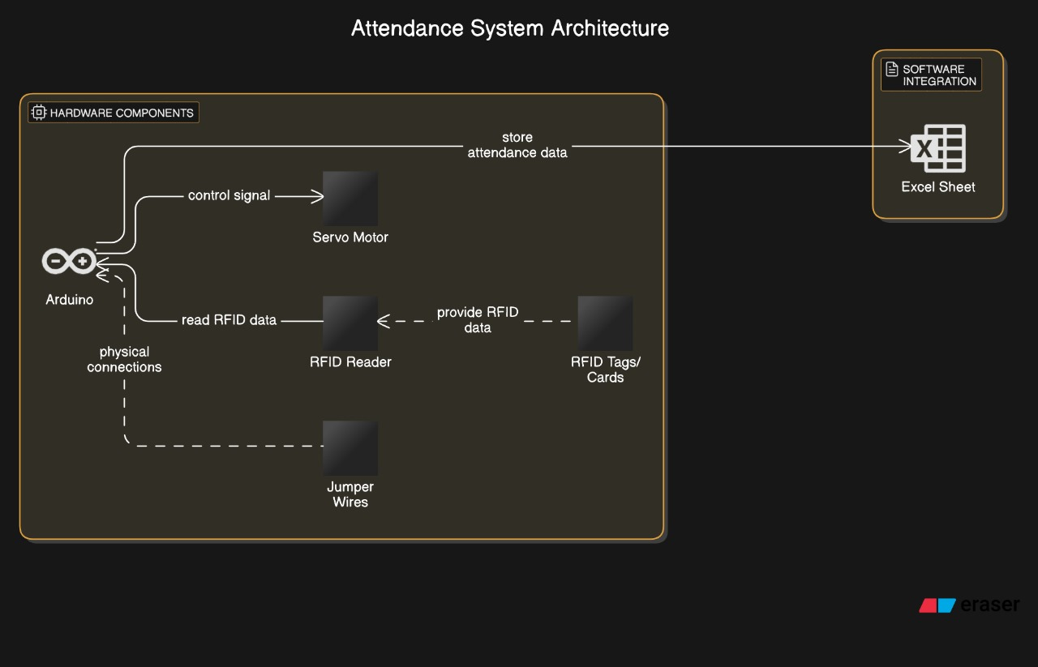

## 

**Explaining the components:**

1. Arduino: The main microcontroller that processes inputs and controls outputs.
2. RFID Reader: Reads the RFID tags/cards when presented.
3. Servo Motor: Controls physical access (e.g., opens a gate or door).
4. Excel Sheet: Logs attendance or access attempts.
5. Jumper Wires: Connects different components.
6. RFID Tags/Cards: Used as ID cards for the system to read and verify

## PROGRAMS

## Code for Arduino-

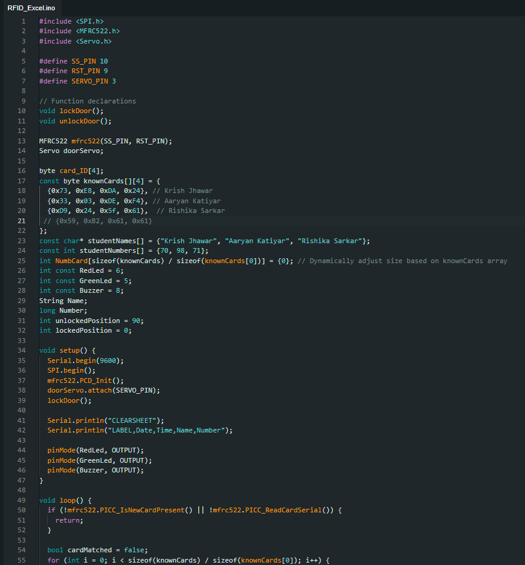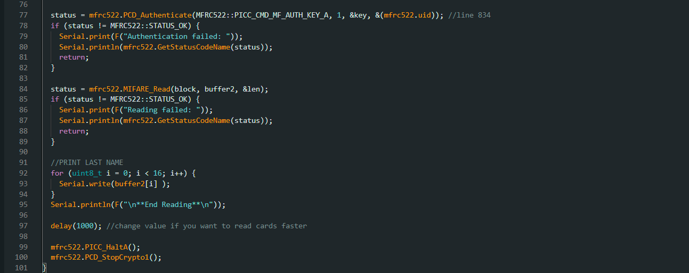

* **Code for Exel-**

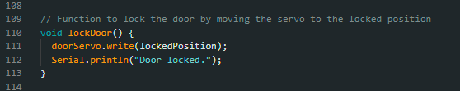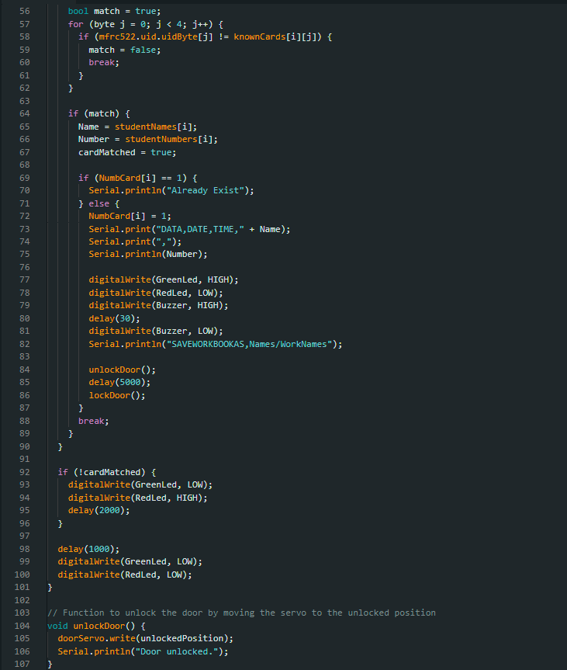

## OUTPUT:

## 

**CONCLUSION:**

In conclusion, the Arduino-based attendance system with RFID technology and a servo motor exemplifies an advanced, automated solution for seamless attendance tracking and access control. This system not only simplifies the attendance process but also addresses key concerns related to security and reliability. By using RFID tags for identification, it provides a quick, contactless, and accurate method for recognizing individuals, eliminating the potential for human error associated with manual sign-ins or traditional ID verification processes.

One of the standout features of this system is its ability to log attendance data in real-time, capturing essential details like name, roll number, date, and time directly into an Excel sheet. This automated record-keeping reduces administrative workload and ensures that attendance data is consistently up-to-date and easily accessible for reporting or auditing purposes.

The addition of a servo motor to control physical access introduces a powerful security feature, ensuring that only authorized individuals can enter the premises. Upon successful tag validation, the servo motor temporarily unlocks the door, allowing access before automatically returning to a locked state, thus maintaining security. The programmed time delay before unlocking adds an extra layer of assurance, ensuring that the system has fully processed and validated each access attempt before granting entry.

This project is a prime example of integrating hardware (Arduino, RFID reader, servo motor) and software (data logging, real-time processing) to create a robust, flexible solution. The system can be further customized or scaled up, adapting easily to different environments like schools, offices, or secured facilities. It not only enhances operational efficiency but also contributes to a safer and more secure environment by combining automated attendance with access control. Overall, this project highlights how modern technologies can work together to streamline processes and strengthen security measures, providing a valuable tool for attendance management in a wide range of applications.

**REFERENCES:**

1. https://youtu.be/GOO84CGBPz8?si=1d6INMzwJN9VrGmz
2. https://srituhobby.com/how-to-make-a-rfid-door-lock-with-arduino/
3. https://ijarsct.co.in/Paper10314.pdf
4. https://papers.ssrn.com/sol3/papers.cfm?abstract_id=3372734